DEPLOYMENT GUIDELINES
FROM: SINMOR UNIPESSOAL LDA
TO: INSTITUTU NASIONAL SEGURANSA SOSIAL (INSS)




On behalf of Provider | On behalf of Project Owner
Name: ……………………………………………………  Title: ………………………………………………………  Date: ……………………………………………………… | Name: ……………………………………………………  Title: ………………………………………………………  Date: ………………………………………………………

Contents
1. Project Overview: 3
2. Definition/abbreviation 3
3. Full Guide: Install and Configure NGINX for Angular Apps + API Proxy 3
- Prerequisites 4
- Step 1: Install NGINX 4
- Step 2: Build Angular Apps 4
- Step 3: Upload Files to Server 4
- Step 4: Configure NGINX Frontends 4
o Finance Module: test.finmod.segurancasocial.gov.tl 4
o Contribution Module: test.contmod.segurancasocial.gov.tl 5
- Step 5: Proxy API to Backend 5
o API: api.testapp.segurancasocial.gov.tl 5
- Step 6: Test and Reload NGINX 6
- Step 7 (Optional): Add HTTPS with Certbot 6
Done! 6

Project Overview:
Project Owner | PREPARE BY
PARTE I:  - Institutu Nasional Seguransa Sosial no Fundu Reserva Seguransa Sosial  (INSS & FRSS)  - Rua de Caicoli, Dili, Timor Leste  - Nú. Telemóvel: 670) 77326929  - Website: Segurancasocial.com | PARTE II  - Sinmor, Unip, Lda  - Rua Fatumeta, Bairo-Pite, Dom Aleixo, Dili Timor-Leste  - Nú. Telemóvel: 3311480 / 77138966
Project Content
- Contract number: N.º 43-AJ (Ajusta Direta) DA/INSS/XII/2024
- Project Name: Manutenção dos Módulos de Contribuições e Financeiro do Sistema de Informação da Segurança Social.
- Contract Singing date:
- Contract Due date: …………….

Definition/abbreviation
Seq | Abbreviation | Detail | Note
1 | INSS | INSTITUTO NACIOAL DA SEGURANÇA SOCIAL
2 | PO | Project Owner: in this case, PO means INSS
3 | Provider | Sinmor Unipessoal Lda
4 | Sinmor | Sinmor Unipessoal Lda
5 | UAC | User Acceptance Test  To show that PO aggree with the work of Provider
6 | RD | Remote Desktop  The computer, machine which PO gives to Provider
7 | DR | Declaration for Remuneration

Full Guide: Install and Configure NGINX for Angular Apps + API Proxy

This guide walks you through:
- Installing NGINX on Ubuntu/Debian
- Building and deploying two Angular apps
- Setting IIS
- Setting up NGINX to serve the frontend apps
- Proxying API requests to a backend server
- (Optional) Adding HTTPS with Certbot

Prerequisites
- A server running Ubuntu/Debian
- Domain names pointing to your server:
  - test.finmod.segurancasocial.gov.tl (Finance module)
  - test.contmod.segurancasocial.gov.tl (Contribution module)
  - api.testapp.segurancasocial.gov.tl (Backend API)

Step 1: Install NGINX
sudo apt update
sudo apt install nginx -y
Check that NGINX is running:
sudo systemctl status nginx

Step 2: Build Angular Apps
On your local machine:
ng build --configuration production
Repeat for each Angular project. You will get:
- dist/finance-app/
- dist/contribution-app/

Step 3: Build Backend and deploy
      - Build code c#
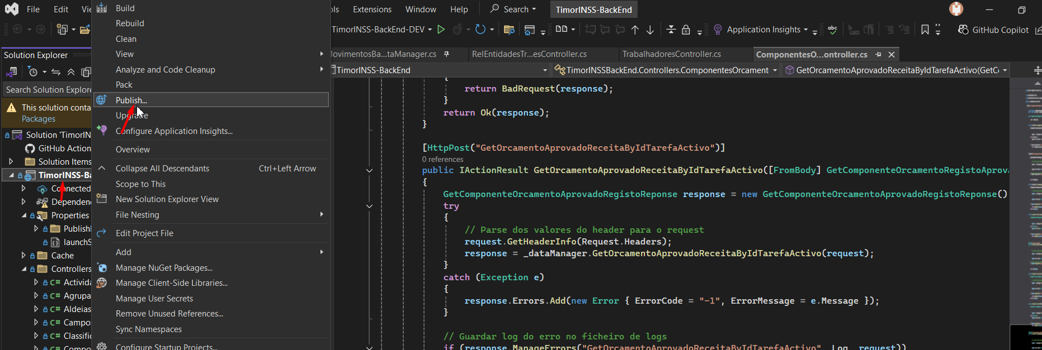
      - Choose forder save this
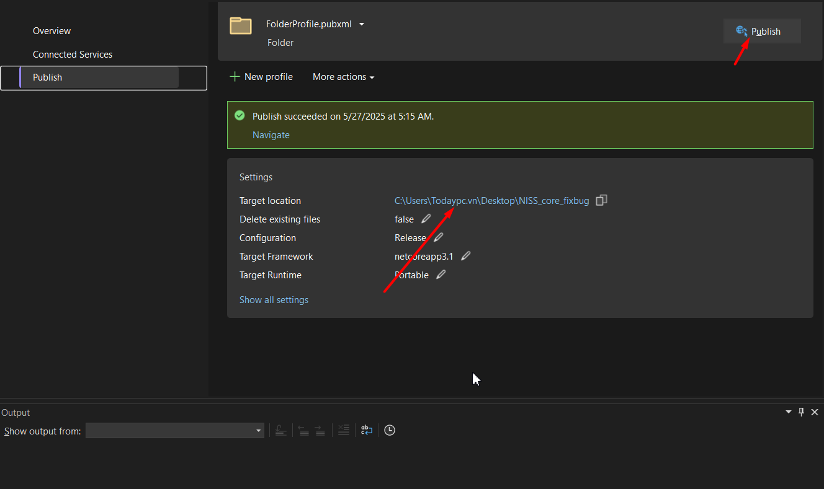

Step 4: Upload Files to Server
Copy each built Angular app to:
scp -r dist/finance-app/* user@server:/var/www/html/finance-app
scp -r dist/contribution-app/* user@server:/var/www/html/contribution-app
Copy backend to sever:
Step 1:
scp -r C:\Users\Todaypc.vn\Desktop\NISS_core_fixbug* user@server:/u01/app/niss_backend
Step 2: Run backend project with DOTNET first
dotnet TimorINSSBackEnd.dll --urls "http://0.0.0.0:5000"

Step 5: Configure NGINX Frontends

Finance Module:

test.finmod.segurancasocial.gov.tl
server {
client_max_body_size 20M;
listen 80;
server_name test.finmod.segurancasocial.gov.tl;

root /var/www/html/finance-app;
index index.html;

location / {
try_files $uri $uri/ /index.html;
}

location ~* \.(?:ico|css|js|gif|jpe?g|png|woff2?|eot|ttf|svg)$ {
expires 6M;
access_log off;
add_header Cache-Control "public";
}
}

Contribution Module: test.contmod.segurancasocial.gov.tl
server {
client_max_body_size 20M;
listen 80;
server_name test.contmod.segurancasocial.gov.tl;

root /var/www/html/contribution-app;
index index.html;

location / {
try_files $uri $uri/ /index.html;
}

location ~* \.(?:ico|css|js|gif|jpe?g|png|woff2?|eot|ttf|svg)$ {
expires 6M;
access_log off;
add_header Cache-Control "public";
}
}
Enable both sites by creating symlinks in /etc/nginx/sites-enabled/.

Step 5: Proxy API to Backend

API: api.testapp.segurancasocial.gov.tl
server {
client_max_body_size 20M;
listen 80;
server_name api.testapp.segurancasocial.gov.tl;

location / {
proxy_pass http://localhost:5000;
proxy_http_version 1.1;
proxy_set_header Upgrade $http_upgrade;
proxy_set_header Connection "upgrade";
proxy_set_header Host $host;
}
}
Replace YOUR_BACKEND_IP with the internal/private IP of your backend service.

Step 6: Test and Reload NGINX
sudo nginx -t
sudo systemctl reload nginx

Step 7 (Optional): Add HTTPS with Certbot
Install Certbot:
sudo apt install certbot python3-certbot-nginx -y
Run SSL setup:
sudo certbot --nginx -d test.finmod.segurancasocial.gov.tl -d test.contmod.segurancasocial.gov.tl -d api.testapp.segurancasocial.gov.tl

Step 8: Result
You now have:
- Angular frontend served on:
  - <http://test.finmod.segurancasocial.gov.tl>
  - <http://test.contmod.segurancasocial.gov.tl>
- API proxied via:
  - <http://api.testapp.segurancasocial.gov.tl>
You can now continue with staging or production configuration.

